PROFESSIONAL EXPERIENCE

BERINDEI FINEAS
FRONT-END DEVELOPER
3/12/2017 -
- 7/1/2018

8/5/2018 -
3/12/2019

3/3/2020 -
1/6/2021

BestTrading.fr
web developer, Timisoara Development/deployment of sites and web apps with UX/UI best practices, mainly focusing on responsiveness and maintenance of code.
Technologies: Wordpress, Joomla, Bootstrap,
Javascript, CSS3 and HTML5

mediatack GmbH
Junior front-end developer, Timisoara Collaborated in a team-focused environment, working on web apps and websites, offered to a diverse industry class of clients. Technologies: Javascript, Bootstrap, Angular 8, HTML5, CSS3.

Dexwell.US
Front-end developer, San Diego
Working on full-stack apps using Angular on Frontend and C# .Net on the backend. We provided web apps dashboards for doctors offices and multinational companies.

EDUCATION
15/8/2015 -
7/22/2018

Bachelor degree in Physics and Informatics and Master in informatics
UVT, Timisoara
Studied quantumum physics and Web development.

CONTACT
SKILLS

frontend skills
Angular 8+ RxJs
Api JavaScript/Type SCript
Http protocol, RESTful services Json
Design Patterns HTML, SCSS,
Bootstrap Git














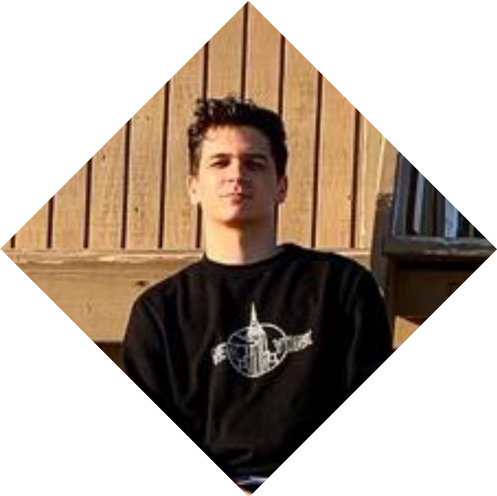
 Anaheim Los Angeles
 7148121511
→ fberindei@dexwell.com

↑ fineas.berindei
 @BFineas
 /fineas.berindei

PROJECTS
Personal Website: https://fineas-portfolio.netlify.app/
Movie App using Javascript, Restful Api: https://movieapp- fineasinc.netlify.app/
Weather App using Javascript, weather Api, Json data, Bootstrap and more: https://weatherapp-fineasinc.netlify.app/
Weather App using Angular 8+, RxJs, TypeScript, Http protocol and more: https://weatherappangular-fineasinc.netlify.app/
Doctor dashboards: Unfortunately the projects are private. Wordpress websites for companies in Real Estate Hotels and so on.

ABOUT ME
I am a very hard working person, who will never stop learning new technologies about web development. In present I am working on a quiz full stack web app who will test kids all over the world about subjects like Biology, Geography, and so on. I am very passionate about what I am doing and I think I am great teammate who likes to help others as well.

